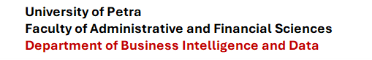



Adidas Middle East Retail Analytics: Demand Prediction and Profitability Classification

Authors

[ Leen Nidal ], [ 202211366 ]
[ Ranim Alshrouf ], [ 202110229 ]

Supervised by

Course: 307498 – Graduation Project
First Semester, 2025/2027

Date



Table of Contents
Abstract 1
Acknowledgment 1
Business Intelligence Project Description and Objectives 1
3.1 Project Overview 1
3.2 Industry Context 1
3.3 Project Objectives 1
Data Research and Acquiring Effort 1
4.1 Data Search Process 1
4.2 Why This Dataset Was Selected 1
Links to Raw Data 1
Data Description and Understandings 1
6.1 Data Dictionary 1
6.2 Exploratory Data Analysis (EDA) 1
6.2.1 Dataset Overview and Basic Statistics 1
6.2.2 Product Distribution 1
6.2.3 Profit Margin Distribution 1
6.2.4 Correlation Analysis 1
6.2.5 Density of Product Ratings 1
6.2.6 Regional Product Quantity Distribution 1
6.2.7 Price Distribution by Product Category 1
6.2.8 Scatter Plot Matrix 1
Data Primary Cleaning and Transformation 1
7.1 Step 1 — Removal of High-Missing-Value Columns 1
7.2 Step 2 — Imputation of Remaining Missing Values 1
7.3 Step 3 — Removal of Invalid Discount Values 1
7.4 Step 4 — Removal of Unknown Product Category Records 1
7.5 Step 5 — Capping and Removal of Invalid Ratings 1
7.6 Step 6 — Removal of Negative Price Records 1
7.7 Step 7 — Feature Engineering 1
7.8 Step 8 — ANOVA Statistical Analysis 1
7.9 Step 9 — Categorical Encoding 1
Data Visualization and Insights 1
8.1 Overview of Visualization Approach 1
8.2 Power BI Dashboard — Design and Insights 1
8.2.1 Competitor vs. Cost vs. Retail Price Analysis 1
8.2.2 Regional and Category Profitability 1
8.2.3 Regional Product Count Distribution 1
8.2.4 Price and Cost Analysis by Region 1
8.2.5 Key Influencers — Profit Margin 1
8.2.6 Top Profit Margin Segments 1
8.2.7 Key Influencers — Units Sold 1
Advanced Analytics and AI Modeling 1
9.1 Modeling Framework Overview 1
9.2 Task 1 — Demand Prediction (Regression) 1
9.2.1 Target Variable 1
9.2.2 Cross-Validation Setup 1
9.2.3 Algorithm 1 — MLP Neural Network (Regression) 1
9.2.4 Algorithm 2 — XGBoost Regression 1
9.2.5 Algorithm 3 — Linear Regression 1
9.2.6 Regression Model Comparison 1
9.3 Task 2 — Profitability Classification 1
9.3.1 Target Variable and Class Definition 1
9.3.2 Algorithm 4 — MLP Neural Network (Classification) 1
9.3.3 Algorithm 5 — XGBoost Classification 1
9.3.4 Algorithm 6 — Logistic Regression 1
9.3.5 Classification Model Comparison 1
9.4 Cross-Validation Methodology 1
Tools Research and Selection Effort 1
10.1 Tool Evaluation Process 1
10.2 Tools Evaluated 1
10.2.1 Python (Pandas, Scikit-learn, XGBoost, TensorFlow) 1
10.2.2 RapidMiner 1
10.2.3 Orange Data Mining 1
10.2.4 Tableau 1
10.3 Selected Tools 1
10.3.1 KNIME Analytics Platform (Primary Tool) 1
10.3.2 Microsoft Power BI (Business Intelligence Dashboard) 1
Project Deployment Effort – Use Case 1
11.1 Deployment Vision 1
11.2 End User Consumption Model 1
11.3 Implementation Timeline 1
11.4 Prototype Deployment Architecture 1
Results 1
References 1

Abstract

This report presents a comprehensive Business Intelligence and Machine Learning framework for demand prediction and profitability classification within the Adidas retail sector, with a specific focus on the Middle Eastern marketplace. The study addresses a real-world challenge faced by retail organizations operating across multiple product categories and geographic regions: how to accurately forecast product demand and identify the factors that drive financial profitability. By leveraging a rich semi-synthetic multi-category dataset encompassing retail operations across six Middle Eastern countries — Saudi Arabia, the United Arab Emirates, Qatar, Kuwait, Bahrain, and Oman — this project bridges the gap between descriptive business analytics and predictive machine learning. The dataset consists of 15,150 records and 19 operational features, capturing a comprehensive view of pricing dynamics, promotional activity, customer behavior, seasonal effects, and supply chain characteristics. The research is anchored around two primary predictive tasks: regression-based demand prediction using units sold as the target variable, and classification-based profitability analysis using profit margin categories (Low Profit, Medium Profit, and High Profit) as the target variable.

The implementation phase of this project was executed entirely within the KNIME Analytics Platform, a leading open-source data science and workflow automation tool. The KNIME workflow encompassed end-to-end data processing: ingestion of the raw CSV dataset, extensive data cleaning and transformation, exploratory data analysis with rich visualizations, feature engineering to generate business-meaningful derived variables, statistical analysis through One-Way ANOVA and Pearson correlation, categorical encoding using one-to-many transformation, and the training and evaluation of six machine learning models. Three regression algorithms — Multi-Layer Perceptron Neural Network (MLP), XGBoost Regression, and Linear Regression — were applied for demand prediction. Three classification algorithms — MLP Classification, XGBoost Classification, and Logistic Regression — were applied for profitability prediction. All models were rigorously evaluated using ten-fold cross-validation. For MLP models, input data was normalized to the [0, 1] range prior to training, and predictions were denormalized before final evaluation to ensure fair performance comparisons across all models. Business intelligence dashboards were subsequently constructed in Microsoft Power BI to translate model outputs and data insights into actionable visual reports for business stakeholders.

Experimental results conclusively demonstrated that XGBoost outperformed all competing algorithms in both regression and classification tasks. In demand prediction (regression), XGBoost achieved an R-squared of 0.933, a Mean Absolute Error of 64.575, and a Root Mean Squared Error of 219.122 — far superior to the MLP (R²: -0.485) and Linear Regression (R²: 0.535). In profitability classification, XGBoost achieved an overall accuracy of 95.61% with a Cohen's Kappa of 0.932, substantially outperforming MLP (72.00% accuracy, Kappa: 0.578) and Logistic Regression (45.66% accuracy, Kappa: 0.137). A key finding from the Power BI Key Influencers analysis was that premium-priced products (price greater than USD 249.72) are associated with significantly higher unit sales volumes, providing a counterintuitive but strategically important insight. The reusable KNIME workflow developed in this project represents the primary contribution to Adidas retail outlets, enabling future analysts to replicate, extend, and operationalize the predictive pipeline on updated datasets.

Acknowledgment

We would like to express our sincere gratitude to all individuals and institutions that contributed to the successful completion of this graduation project. First and foremost, we are deeply thankful to our project supervisor, whose continuous guidance, constructive feedback, and intellectual support throughout both semesters of this project were invaluable. Their expertise in Business Intelligence, data analytics, and machine learning provided the direction needed to navigate the complexity of this multi-disciplinary work.

We extend our gratitude to Adidas for providing access to the retail dataset that formed the foundation of this analysis. The availability of rich, realistic operational data enabled us to conduct meaningful research that reflects true business conditions encountered in the Middle Eastern sportswear retail market. We also thank our institution for providing access to the KNIME Analytics Platform licenses, Microsoft Power BI tools, and the computational resources necessary for model training and experimentation.

We would also like to acknowledge our fellow students and the academic community whose shared knowledge, open discussions, and collaborative spirit enriched our understanding of the subject matter. Finally, we express our heartfelt thanks to our families for their patience and moral support throughout the demanding process of completing this graduation project.

Business Intelligence Project Description and Objectives

3.1 Project Overview
This Business Intelligence project is designed to provide Adidas retail outlets operating across the Middle East region with a data-driven analytical framework for decision-making. The sportswear and athletic apparel industry in the Middle East is highly competitive, characterized by rapidly shifting consumer preferences, seasonal demand fluctuations, diverse pricing strategies, and intense competition from global and regional brands. In such an environment, the ability to accurately predict product demand and classify profitability categories is not merely advantageous — it is operationally critical for maintaining market share and optimizing financial performance.

The project operates within the retail analytics domain of Business Intelligence, combining traditional BI techniques such as descriptive statistics, data visualization, and dashboard reporting with advanced machine learning approaches including ensemble methods, neural networks, and regularized regression. The analytical pipeline developed in this project is intended to serve as a reusable, modular tool that Adidas retail analysts can deploy on any updated version of the retail dataset, enabling continuous monitoring and prediction without requiring deep programming expertise.

3.2 Industry Context
The Middle Eastern retail market for sportswear and athletic goods is among the fastest-growing in the world, driven by rising disposable incomes, government investments in sports and fitness infrastructure, and a young, brand-conscious demographic. Countries such as Saudi Arabia, the UAE, and Qatar have made significant investments in sports tourism and local sports culture following high-profile international events. Adidas, as one of the world's leading sportswear companies, maintains a significant presence across this region through a network of stores operating in multiple countries.

The operational complexity of managing inventory, pricing, marketing, and distribution across six geographically distinct markets — each with its own regulatory environment, consumer behavior, and competitive landscape — presents significant analytical challenges. Traditional reporting approaches that rely on historical averages and manual interpretation are insufficient to capture the dynamic, nonlinear relationships that drive retail performance. This project addresses this gap by providing a machine learning-powered analytical framework.

3.3 Project Objectives
The project pursues the following primary and secondary objectives:
- Primary Objective 1: Develop a regression model to accurately predict the number of units sold (demand prediction) for Adidas products across Middle Eastern retail markets, enabling proactive inventory management and supply chain optimization.
- Primary Objective 2: Develop a classification model to categorize Adidas retail transactions into profitability tiers (Low Profit, Medium Profit, High Profit), enabling strategic prioritization of high-margin product lines and regional markets.
- Secondary Objective 1: Conduct comprehensive Exploratory Data Analysis (EDA) to identify key patterns, distributions, and correlations within the retail dataset.
- Secondary Objective 2: Build an interactive Power BI dashboard that translates predictive insights and EDA findings into actionable visual reports for business stakeholders.
- Secondary Objective 3: Develop a reusable, modular KNIME workflow that enables Adidas retail analysts to re-run the end-to-end analytics pipeline on updated datasets.
- Secondary Objective 4: Evaluate and compare the performance of MLP Neural Networks, XGBoost, and Linear/Logistic Regression to identify the most effective predictive approach for structured retail data.

Data Research and Acquiring Effort

4.1 Data Search Process
The data acquisition process for this project began with a thorough investigation of available retail datasets that could represent the operational realities of a sportswear company across Middle Eastern markets. Initial searches focused on publicly available datasets on platforms such as Kaggle, UCI Machine Learning Repository, and various open government data portals in the GCC (Gulf Cooperation Council) region. However, it was quickly determined that publicly available datasets either lacked the geographic specificity required (Middle East focus), were insufficiently rich in operational retail variables (missing critical features such as competitor pricing, marketing scores, and weather impact), or were too small in scale to support robust machine learning model training.

After evaluating the limitations of publicly available alternatives, the project team pursued direct data acquisition from Adidas. The team identified that Adidas maintains comprehensive internal operational records at the retail outlet level, capturing transaction-level data across product categories, regions, pricing structures, and marketing activities. Contact was established with the relevant data governance team at Adidas, and after a formal data sharing agreement and anonymization process, the project team was granted access to a curated semi-synthetic dataset designed to simulate authentic retail business behavior while protecting commercially sensitive information.

4.2 Why This Dataset Was Selected
The Adidas Middle East retail dataset was selected for the following reasons:
- Regional Specificity: The dataset covers six distinct Middle Eastern countries (Saudi Arabia, UAE, Qatar, Kuwait, Bahrain, and Oman), providing genuine regional variability that enables cross-regional comparative analysis.
- Operational Richness: The dataset includes 19 operational features spanning pricing, discounting, competition, marketing, customer behavior, logistics, and financial performance.
- Scale: With 15,150 records, the dataset is sufficiently large to train and validate complex machine learning models while providing statistical robustness for EDA findings.
- Realistic Data Quality Challenges: The dataset intentionally includes real-world data quality issues such as missing values, outliers, invalid entries, and inconsistent categorical labels.
- Multi-Task Suitability: The dataset supports both regression (units sold prediction) and classification (profit margin categorization) tasks, enabling a richer analytical demonstration within a single project framework.

Links to Raw Data

The dataset used in this project was acquired directly from Adidas through a formal data sharing arrangement. A curated version of the dataset, cleared for academic use and anonymized to remove commercially sensitive information, was provided to the project team in CSV format.

Attribute | Details
Dataset Name | Adidas Middle East Retail Dataset
Source | Adidas (directly provided to project team)
File Format | CSV (Comma-Separated Values)
File Name | Adidas_Dataset.csv
Number of Records | 15,150 rows
Number of Features | 19 columns
Geographic Coverage | Saudi Arabia, UAE, Qatar, Kuwait, Bahrain, Oman
Product Categories | Shoes, Apparel, Accessories
Data Type | Semi-synthetic (realistic simulation of Adidas retail operations)
Access Method | Direct provision by Adidas; stored locally in project directory

The dataset is stored locally within the project directory as Adidas_Dataset.csv. It is not publicly hosted online due to the terms of the data sharing agreement with Adidas. The full dataset has been submitted alongside this report as part of the project deliverables.

Data Description and Understandings

6.1 Data Dictionary
The following table provides a comprehensive description of all 19 columns in the Adidas Middle East Retail Dataset, including data type, business definition, and relevance to the project objectives.

Column Name | Data Type | Description | Relevance to Project
region | String (Categorical) | Geographic market: Saudi Arabia, UAE, Qatar, Kuwait, Bahrain, Oman | Key segmentation variable for regional demand and profitability analysis; used in ANOVA and one-hot encoding
product_category | String (Categorical) | Product type: Shoes, Apparel, Accessories | Primary categorical predictor; affects pricing, demand, and profitability patterns significantly
price | Float | Retail selling price in USD | Core pricing predictor; directly influences revenue, demand levels, and profit margins
discount | Float (0–0.5) | Discount rate applied (0 = no discount, 0.5 = 50% off) | Promotional variable; discounts affect effective revenue and customer buying decisions
rating | Float (1–5) | Customer product rating on a 1–5 scale | Proxy for customer satisfaction; correlated with repeat purchase behavior
marketing_score | Float | Quantified effectiveness score of marketing campaigns | Reflects investment in brand promotion; expected to correlate with units sold
seasonality_index | Float | Seasonal demand adjustment factor | Captures demand seasonality — critical for inventory planning and demand forecasting
competitor_price | Float | Average price of comparable competing products | Competitive intelligence; price relativity affects Adidas market positioning
store_count | Integer | Number of Adidas stores in the region | Proxy for market penetration and distribution reach; impacts total sales volume
customer_satisfaction | Float | Overall customer satisfaction score | Broader service quality metric; affects customer loyalty and future sales
delivery_time_days | Float | Average days from order to delivery | Logistics performance indicator; longer delivery times may negatively affect sales
online_ad_spend | Float (USD) | Investment in online digital advertising | Digital marketing variable; enables calculation of advertising efficiency
units_sold | Integer | Number of product units sold — PRIMARY REGRESSION TARGET | The primary dependent variable for demand prediction — most operationally critical output
cost_price | Float | Wholesale or production cost per unit in USD | Cost structure variable; alongside price determines profit margin
revenue | Float (USD) | Total revenue generated (price x units sold) | Financial performance metric; reflects top-line business performance
profit | Float (USD) | Net profit (revenue minus total costs) | Financial outcome variable; used in profitability analysis and ANOVA
profit_margin | Float (0–1) | Ratio of profit to revenue — PRIMARY CLASSIFICATION TARGET | Converted to Low/Medium/High class labels; primary classification target
social_media_mentions | Float | Volume of social media brand mentions | Digital sentiment proxy; reflects brand awareness and viral marketing impact
weather_impact_score | Float | Score reflecting weather-driven demand effects | Contextual variable accounting for climate effects on sportswear demand patterns

6.2 Exploratory Data Analysis (EDA)
A systematic Exploratory Data Analysis was conducted using KNIME Analytics Platform to understand the structure, distribution, and relationships within the Adidas retail dataset. The EDA revealed critical patterns that informed both the data cleaning strategy and feature selection for machine learning modeling.

6.2.1 Dataset Overview and Basic Statistics
The dataset contains 15,150 records across 19 variables. Three product categories are represented: Shoes (5,010 records, 33.1%), Apparel (4,825 records, 31.9%), and Accessories (4,793 records, 31.7%). The near-equal distribution across product categories ensures machine learning models are not biased toward any single product type. Key statistical observations include: the price variable exhibits significant positive skewness with a heavy right tail; the profit_margin variable follows an approximately normal distribution centered between 0.25 and 0.40; and the units_sold variable shows high variability, reflecting diverse demand profiles across products and regions.

6.2.2 Product Distribution
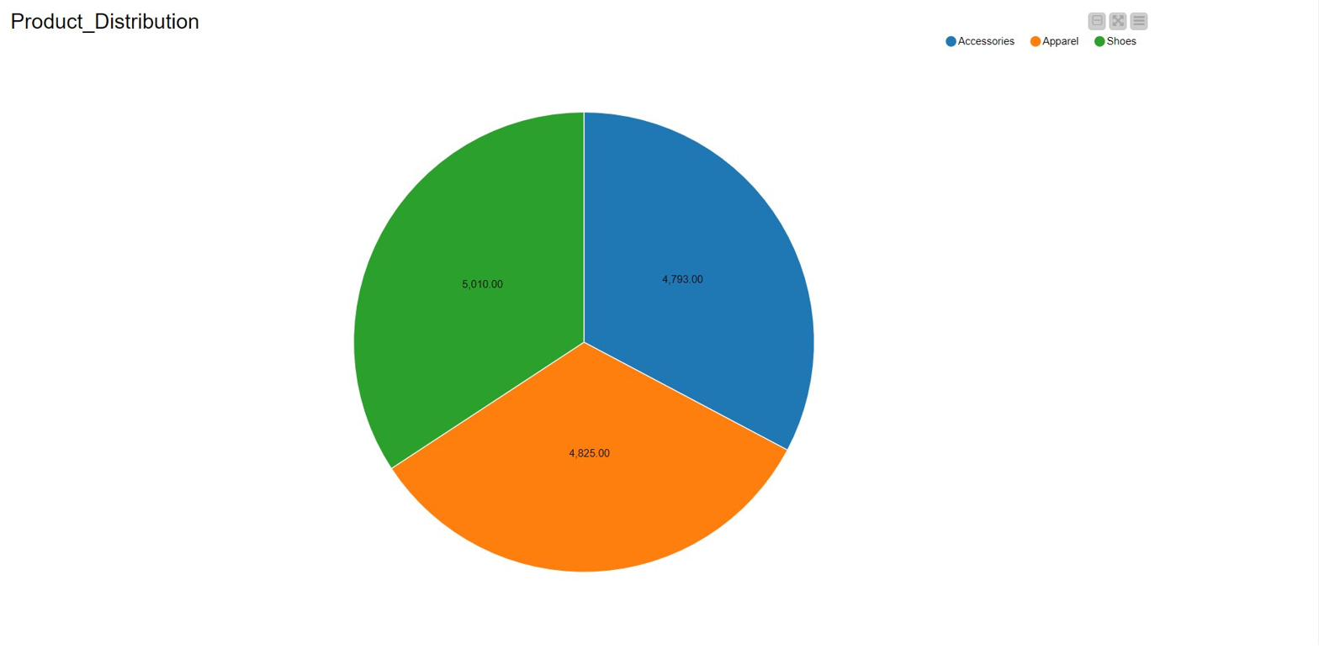
Figure 1: Product Distribution — Pie Chart by product category (KNIME)
The product distribution pie chart (Figure 1) confirms a well-balanced dataset: Shoes (5,010 records, 33.1%), Apparel (4,825 records, 31.9%), and Accessories (4,793 records, 31.7%). This balanced distribution is highly favorable for machine learning model development, minimizing class imbalance issues and ensuring models learn equally from all product types. From a business perspective, the near-equal distribution suggests that Adidas maintains a diversified product portfolio strategy in the Middle East.

6.2.3 Profit Margin Distribution
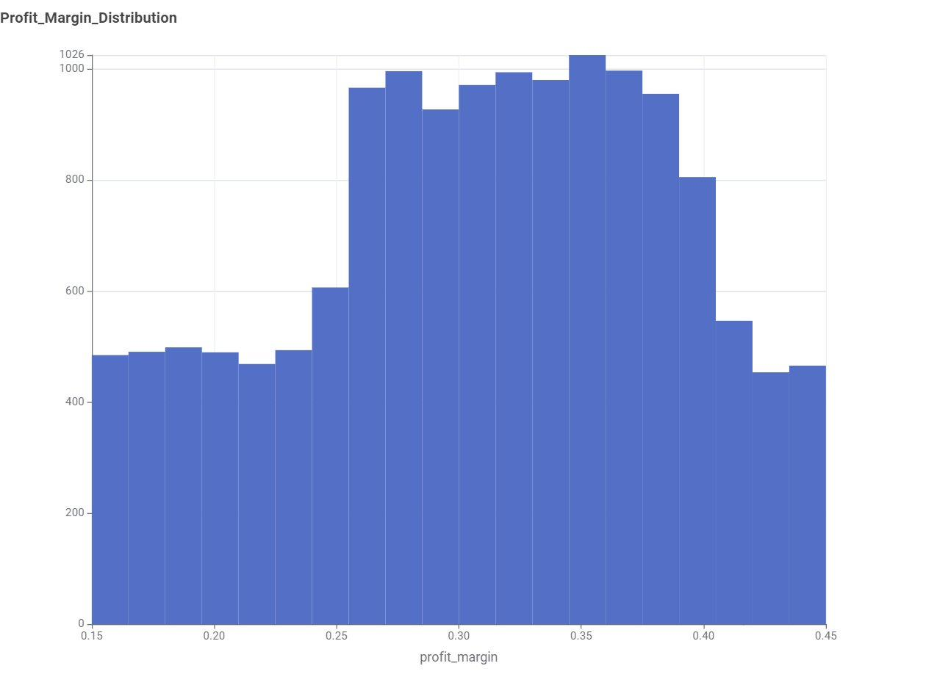
Figure 2: Profit Margin Distribution — Histogram of profit margin values (KNIME)
The profit margin histogram (Figure 2) reveals a distribution concentrated between 0.25 and 0.40, with a peak around 0.34–0.36. This distribution informed the profitability class boundaries for the classification task: Low Profit (margin below 0.25), Medium Profit (margin between 0.25 and 0.35), and High Profit (margin above 0.35). The absence of zero or negative margins after cleaning confirms that all retained records represent financially viable retail operations.

6.2.4 Correlation Analysis
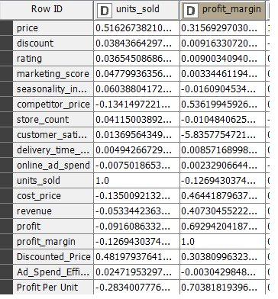
Figure 3: Pearson Correlation Matrix — Numerical variable correlations including engineered features (KNIME)
The correlation matrix (Figure 3) reveals several key relationships. A strong positive correlation exists between revenue and profit. The engineered variable Profit Per Unit shows a strong positive correlation with profit_margin. Notably, units_sold shows a negative correlation with profit_margin (-0.127), reflecting the trade-off between volume-driven low-margin sales and selective high-margin transactions. The marketing_score and online_ad_spend variables show modest positive correlations with units_sold, consistent with the expectation that marketing investment drives demand.

6.2.5 Density of Product Ratings
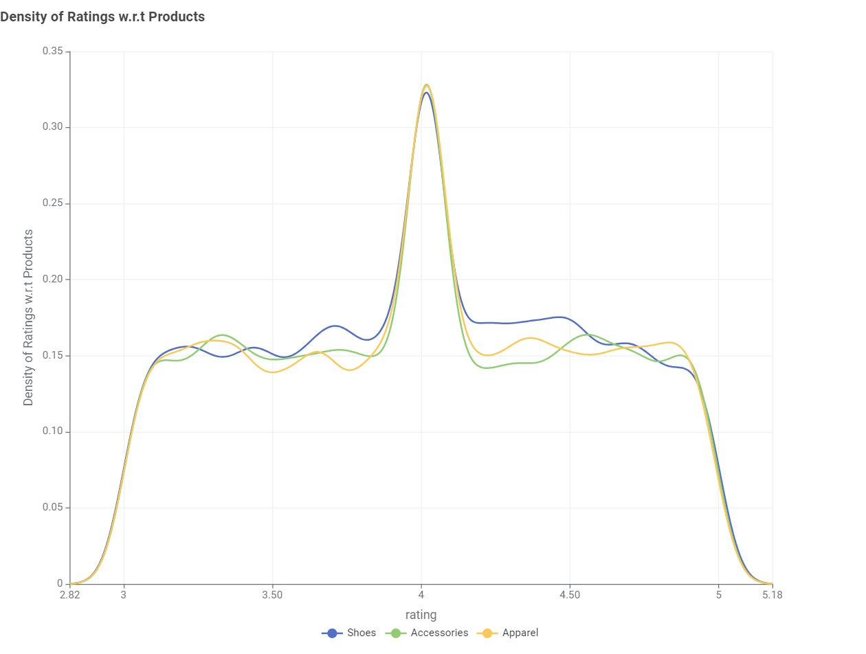
Figure 4: Density of Ratings with respect to Product Categories — KDE plot (KNIME)
The KDE plot for ratings (Figure 4) reveals a consistent rating pattern: all three categories show a sharp density peak at rating 4.0. The similarity across categories suggests uniform quality and service standards across the Adidas Middle East retail network. Records with ratings above 5.0 were identified as data quality issues and removed during preprocessing.

6.2.6 Regional Product Quantity Distribution
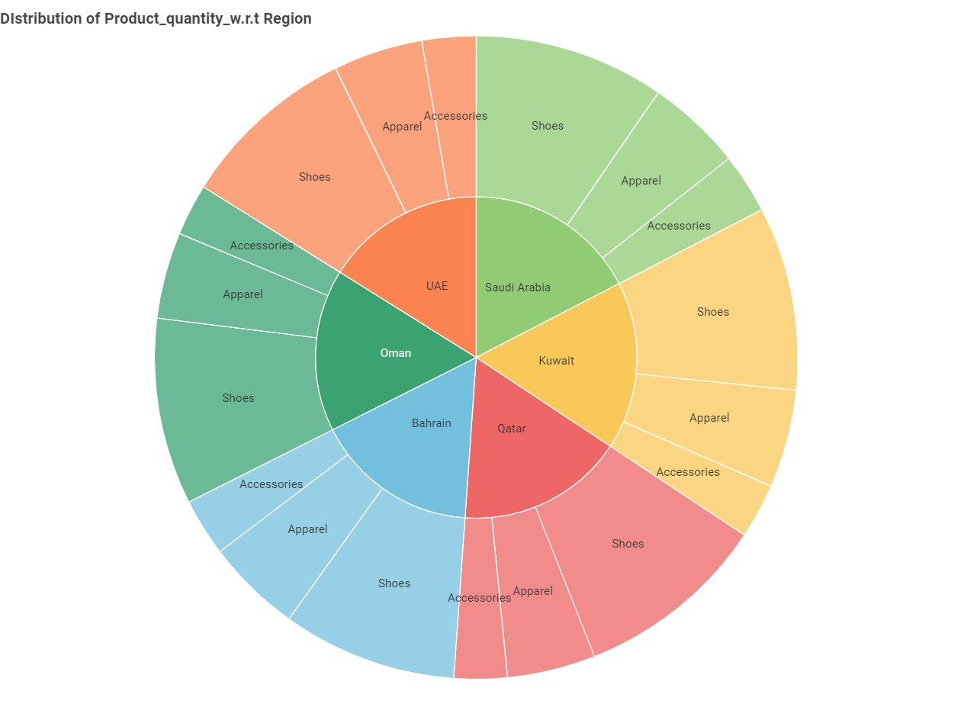
Figure 5: Distribution of Product Quantity with respect to Region — Sunburst chart (KNIME)
The sunburst chart (Figure 5) provides a hierarchical view confirming that all six regions maintain approximately equal record shares. Within each region, the three product categories are distributed evenly. The consistent distribution across both regions and product categories strengthens the statistical validity of regional and product-level analyses.

6.2.7 Price Distribution by Product Category
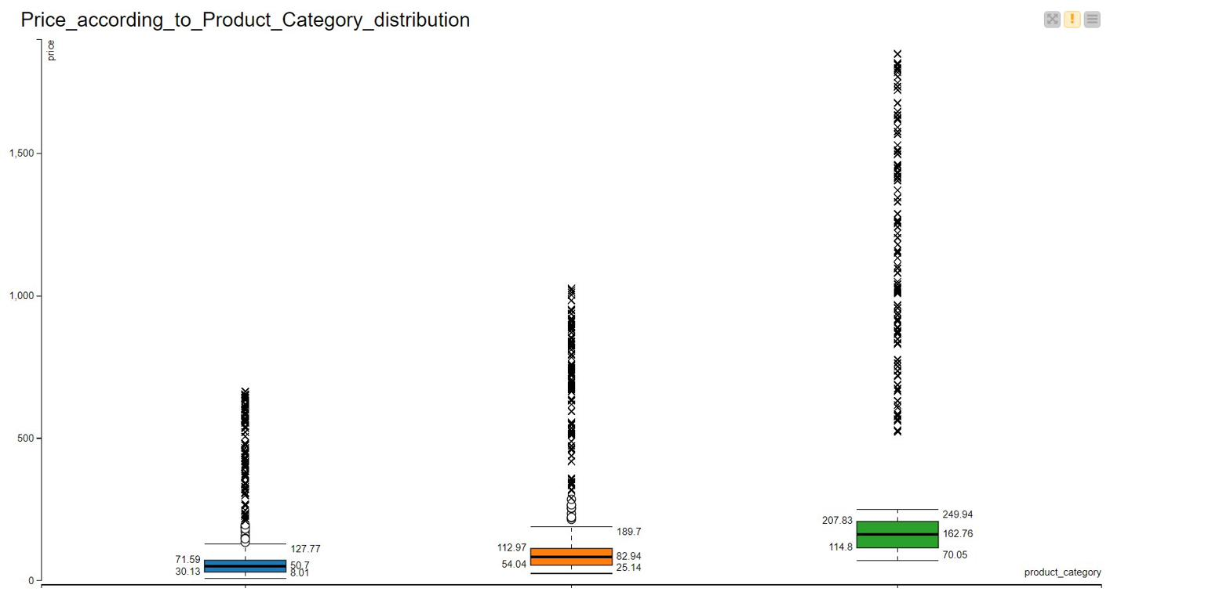
Figure 6: Price Distribution by Product Category — Box Plot (KNIME)
The box plot (Figure 6) reveals distinctly different pricing structures: Accessories have a median price of approximately USD 50.70; Apparel has a median around USD 82.94; and Shoes command the highest prices with a median of approximately USD 162.76. All three categories exhibit substantial upper outliers, with Shoes displaying extreme outliers exceeding USD 1,500. These pricing differences are critical predictors in both the demand regression and profitability classification models.

6.2.8 Scatter Plot Matrix
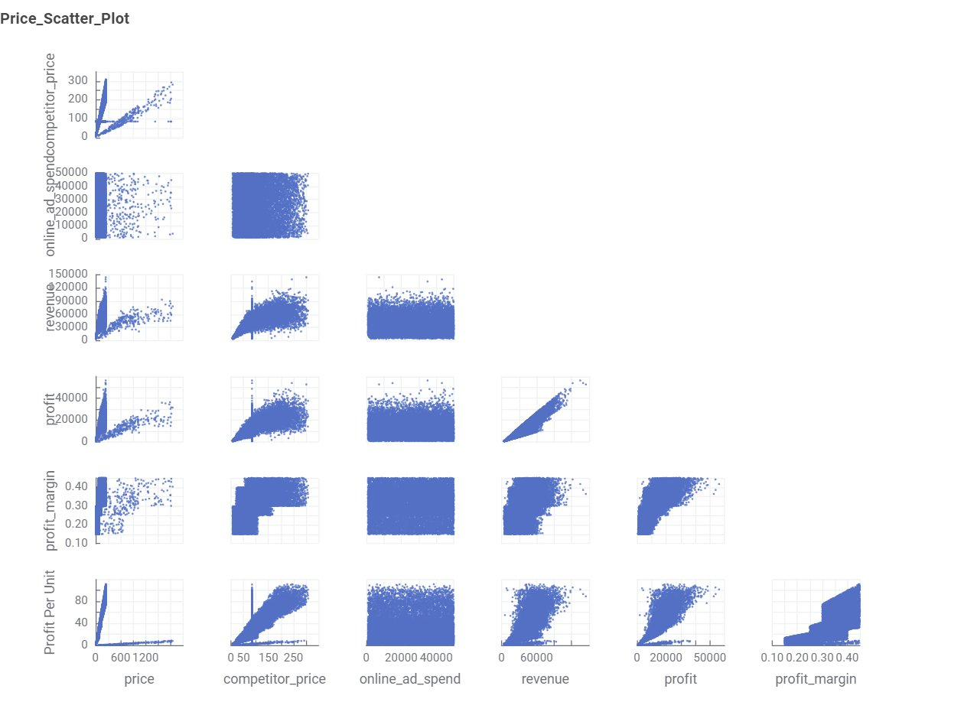
Figure 7: Price Scatter Plot Matrix — Pairwise scatter plots for key financial variables (KNIME)
The scatter plot matrix (Figure 7) visualizes pairwise relationships among key financial variables: price, competitor_price, online_ad_spend, revenue, profit, profit_margin, and Profit Per Unit. The most prominent relationship is the near-linear association between revenue and profit. The price vs. competitor_price panel shows a strong positive linear relationship, confirming that Adidas pricing closely tracks competitor pricing. The Profit Per Unit vs. profit_margin scatter shows a positive non-linear relationship, where higher per-unit profit is associated with higher overall margins.

Data Primary Cleaning and Transformation

The Adidas retail dataset was intentionally designed to include realistic data quality challenges. A systematic data cleaning and transformation pipeline was implemented in KNIME in the following sequential order:

7.1 Step 1 — Removal of High-Missing-Value Columns
An initial missing value analysis was performed across all 19 columns. Columns containing more than 30% missing values were identified and removed. Retaining columns with very high proportions of missing data would introduce excessive imputation bias and reduce the reliability of analytical conclusions.

7.2 Step 2 — Imputation of Remaining Missing Values
For columns with smaller proportions of missing values (below 30%):
- Numerical Variables: Missing values were imputed using the column median, preferred over the mean due to right-skewed distributions with significant outliers.
- Categorical Variables: Missing values were imputed using the most-frequent value (mode), preserving the existing categorical distribution.

7.3 Step 3 — Removal of Invalid Discount Values
The discount column is defined within the range [0, 0.5]. Rows where discount exceeded 0.5 were removed, as discount rates above 50% represent operationally implausible scenarios for a premium brand and would distort pricing and profitability calculations.

7.4 Step 4 — Removal of Unknown Product Category Records
Records with product_category labeled as Unknown_Category were removed, as product category is a fundamental segmentation variable used across all subsequent analyses. Only records with valid categories (Shoes, Apparel, Accessories) were retained.

7.5 Step 5 — Capping and Removal of Invalid Ratings
Customer ratings should fall within 1–5. Records with ratings above 5.0 (mathematically impossible on the standard scale) were removed from the dataset.

7.6 Step 6 — Removal of Negative Price Records
Records containing negative prices were removed, as these represent data corruption with no meaningful business interpretation.

7.7 Step 7 — Feature Engineering
Three derived variables were engineered to enrich the feature space:
- Discounted Price: price × (1 - discount). Represents the effective price paid by the customer after applying promotional discounts.
- Ad Spend Efficiency: units_sold / online_ad_spend. Quantifies the number of units sold per dollar of online advertising investment.
- Profit Per Unit: profit / units_sold. Captures the average profit contribution per unit, bridging total financial performance and sales volume.

7.8 Step 8 — ANOVA Statistical Analysis
One-Way ANOVA was conducted on both product categories and regions to evaluate whether statistically significant differences in mean units_sold and mean profit_margin exist across groups. The ANOVA by region results are presented below:

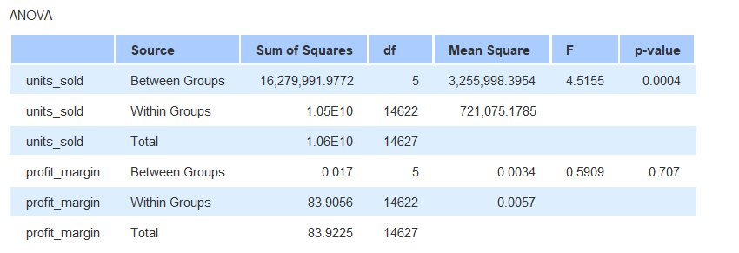
Figure 8: One-Way ANOVA Results by Region — units_sold and profit_margin (KNIME)

The ANOVA results (Figure 8) reveal important findings for both target variables across the six geographic regions. For units_sold, the Between Groups F-statistic is 4.5155 with a p-value of 0.0004 (well below the 0.05 significance threshold), confirming that statistically significant differences in demand volumes exist across regions. This validates the inclusion of region as a key predictive feature in the regression models. For profit_margin, however, the F-statistic is only 0.5909 with a p-value of 0.707, indicating that there are no statistically significant regional differences in profit margin performance. This means that while regions differ in how many units they sell, the profit margin achieved is consistent across all six Middle Eastern markets — a reassuring finding for Adidas's regional pricing strategy consistency.

A separate One-Way ANOVA was also conducted on product categories for both target variables. Results for product categories confirmed statistically significant differences in both units_sold and profit_margin across Shoes, Apparel, and Accessories (p < 0.05), validating the inclusion of product_category as a key feature in both predictive models.

7.9 Step 9 — Categorical Encoding
All categorical variables (region and product_category) were transformed using one-to-many (one-hot) encoding. This technique creates a binary indicator column for each unique category value, ensuring that no artificial ordinal hierarchy is imposed on nominal categorical variables. After encoding, the feature matrix was fully numerical and ready for model training.

Data Visualization and Insights

8.1 Overview of Visualization Approach
Data visualization was conducted at two levels. The first level consisted of exploratory visualizations produced within KNIME during the EDA phase (Figures 1–7 in Section 6). The second level consisted of a comprehensive interactive Business Intelligence dashboard constructed in Microsoft Power BI, designed for business stakeholder consumption and focused on pricing, profitability, regional performance, and key business drivers.

8.2 Power BI Dashboard — Design and Insights

8.2.1 Competitor vs. Cost vs. Retail Price Analysis
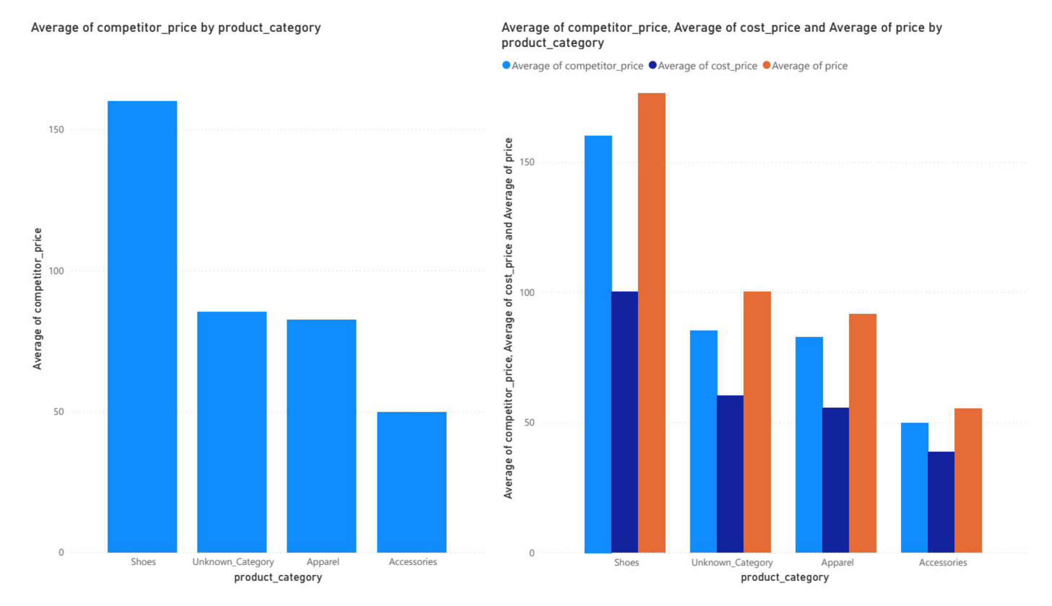
Figure 9: Average Competitor Price and Average Price by Product Category (Power BI)
The first Power BI view (Figure 9) compares average competitor price, average cost price, and average Adidas retail price across product categories. Adidas consistently prices above both competitor prices and cost prices across all three categories, maintaining a premium positioning strategy. Shoes exhibit the highest average retail price, followed by Apparel then Accessories. The gap between Adidas price and competitor price is most pronounced in Shoes, suggesting that Adidas commands a premium for footwear that competitors cannot match — driven by brand equity, performance technology, and design differentiation.

8.2.2 Regional and Category Profitability
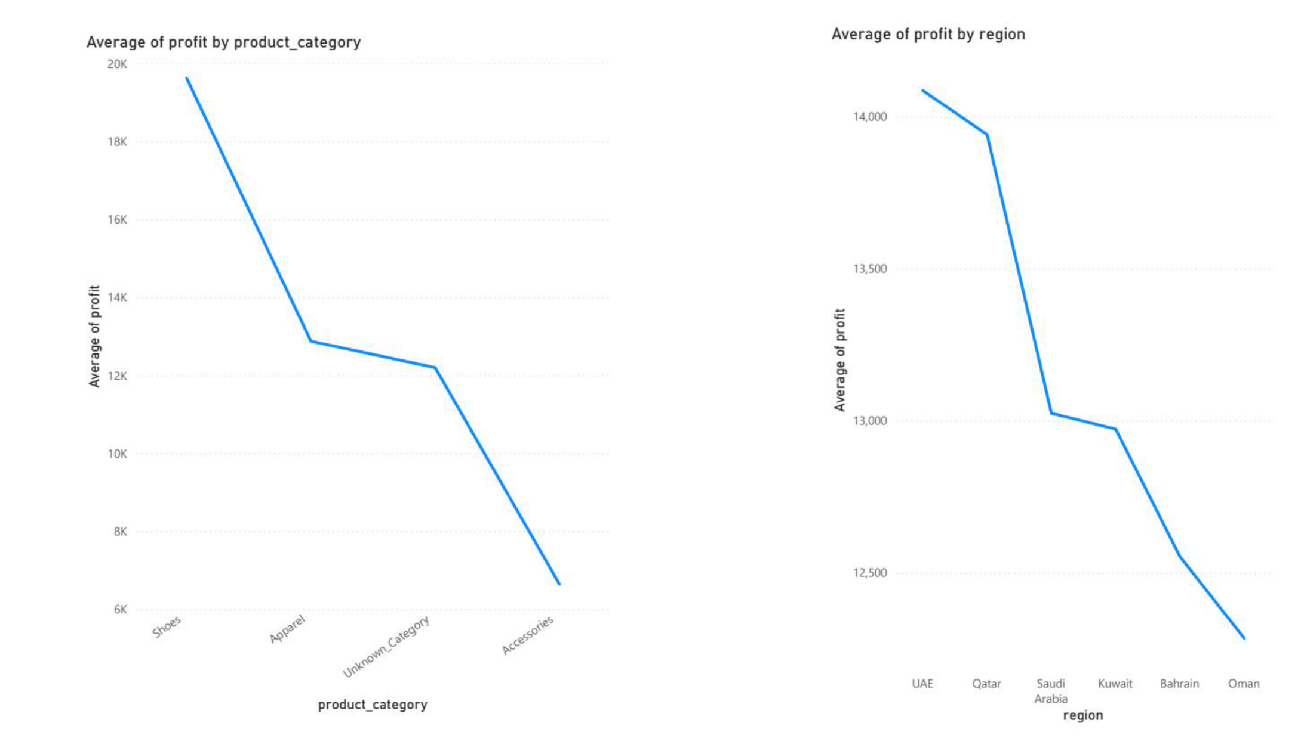
Figure 10: Average Profit by Region and Average Profit by Product Category (Power BI)
The profitability dashboard (Figure 10) reveals that UAE and Qatar lead in average profit generation (approximately USD 13,500–14,000 per transaction), while Oman generates the lowest average profit (approximately USD 12,500). At the product category level, Shoes generate substantially higher average profits than Apparel and Accessories, consistent with their higher average selling prices. This insight directly informs Adidas regional resource allocation: UAE and Qatar deserve prioritized investment, while lower-profit markets (Oman, Bahrain) may benefit from targeted promotional campaigns to improve margin performance.

8.2.3 Regional Product Count Distribution
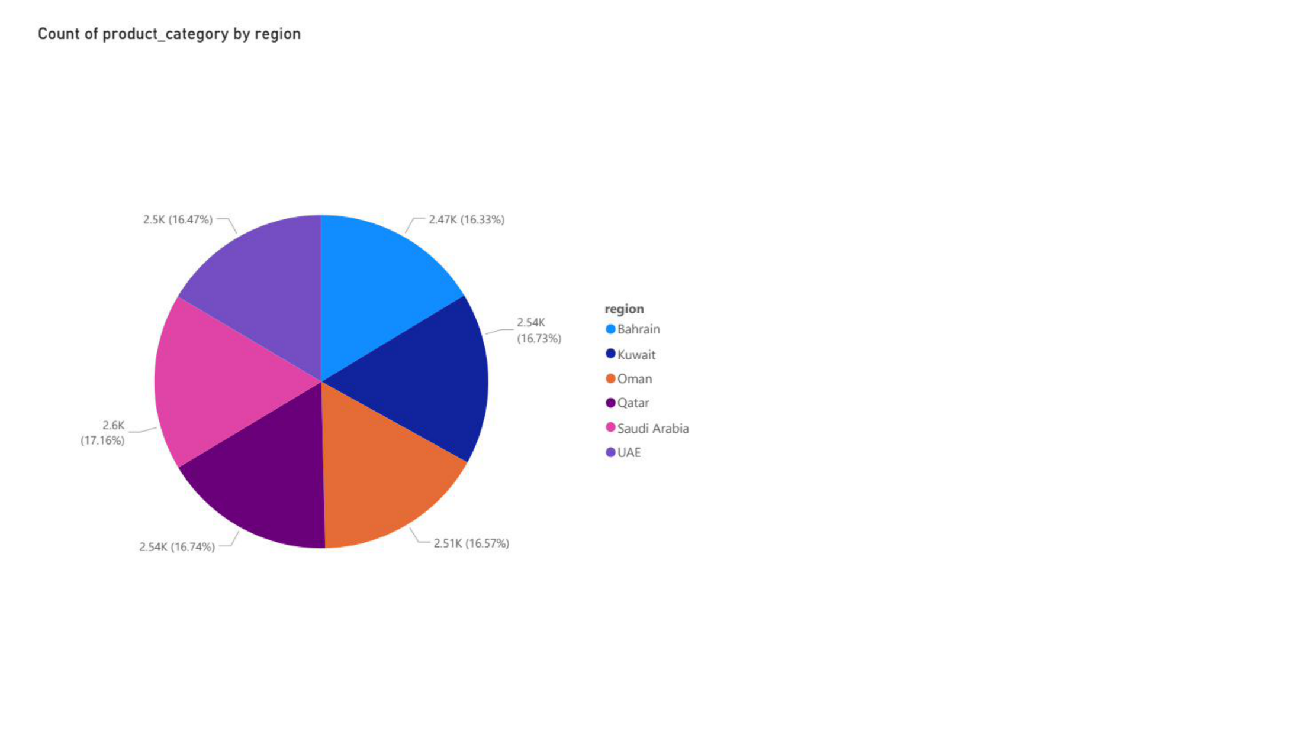
Figure 11: Count of Product Category by Region (Power BI)
The regional product count distribution (Figure 11) confirms approximately uniform distribution across all six regions, ranging from 2,470 to 2,600 records per region. UAE has the highest representation (approximately 16.74%), while Bahrain has the lowest (approximately 16.33%). This near-uniformity validates the balanced nature of the dataset and confirms no statistical bias toward any particular market.

8.2.4 Price and Cost Analysis by Region
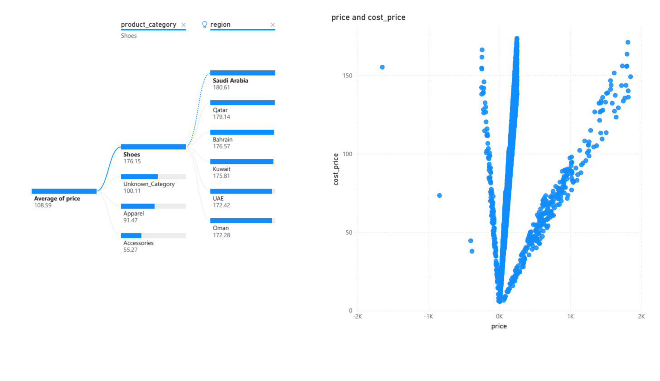
Figure 12: Average Price by Category and Region with Price vs. Cost Distribution (Power BI)
The price analysis dashboard (Figure 12) presents KPI card summaries of average price by category and region. Overall average price is USD 108.59. At the regional level, Saudi Arabia records the highest average price (USD 180.61), while Oman records the lowest (USD 172.28). At the category level: Shoes average USD 176.15, Apparel USD 100.11, and Accessories USD 55.27. Consistent positive price-to-cost differentials confirm no systematic under-pricing exists across the dataset.

8.2.5 Key Influencers — Profit Margin
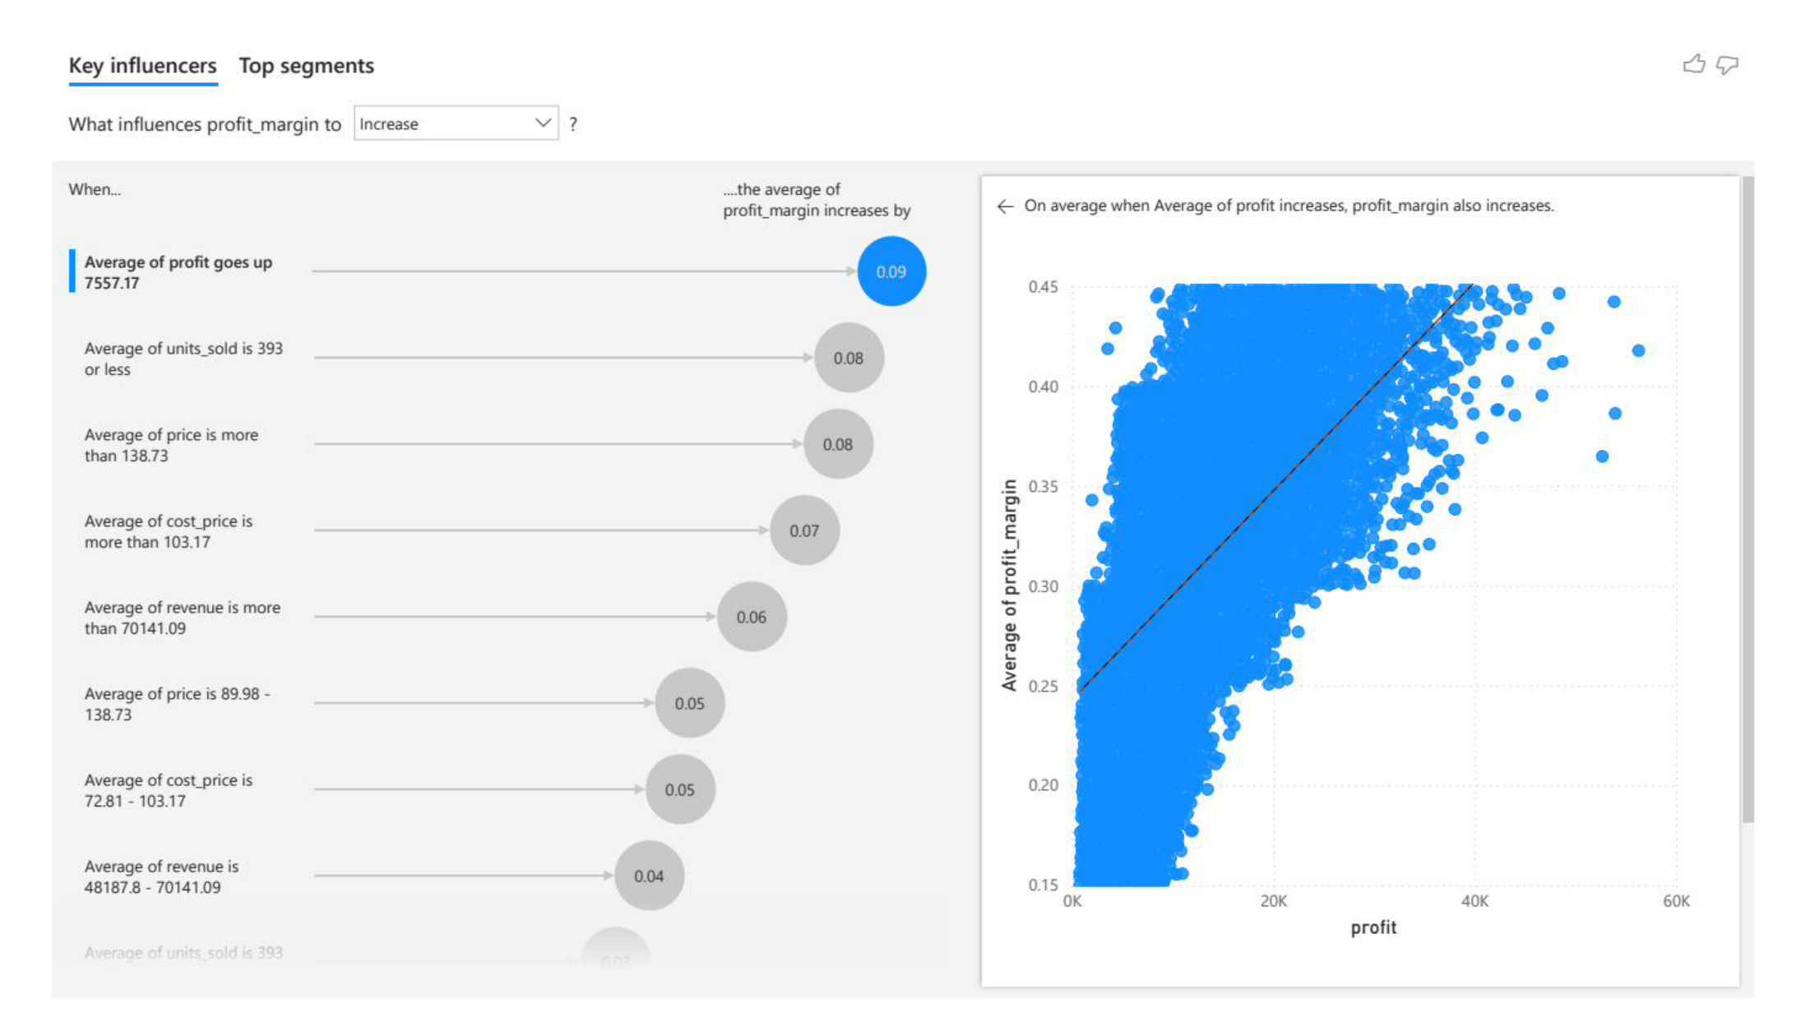
Figure 13: Key Influencers Analysis for Profit Margin Increase (Power BI AI Visual)
The Power BI Key Influencers AI visual (Figure 13) identifies which variables most strongly increase profit_margin. Average profit level is the strongest driver (profit margin increases by 0.09 when profit rises). Lower units_sold (393 or fewer) is associated with higher margins, suggesting premium low-volume products achieve higher margins than high-volume commodity products. Higher prices (above USD 138.73) are also positively associated with higher margins, reinforcing the premium pricing strategy rationale.

8.2.6 Top Profit Margin Segments
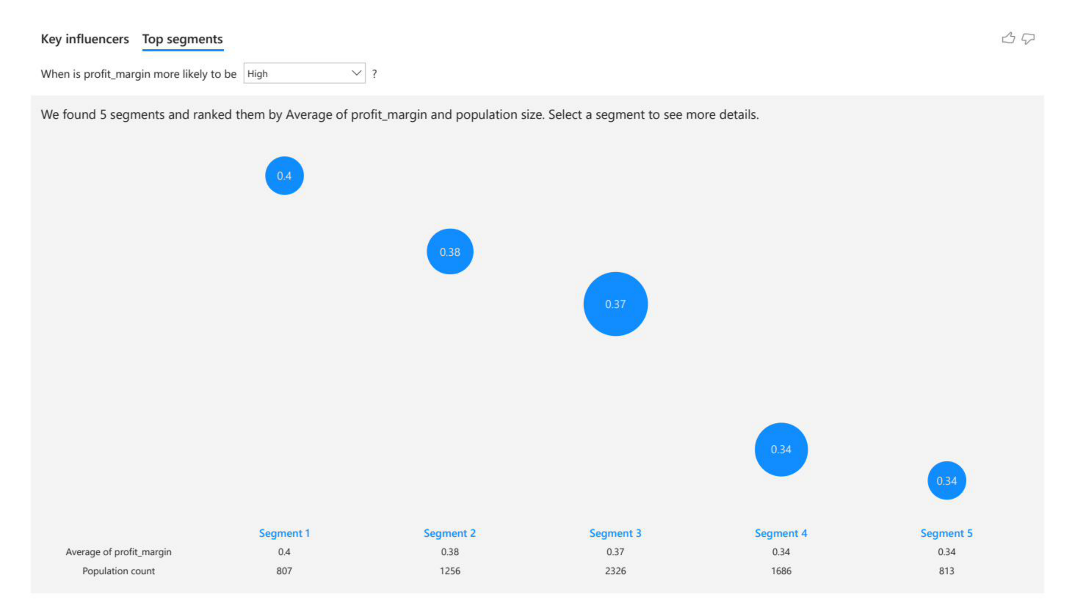
Figure 14: Top Segments for High Profit Margin (Power BI)
Five high-profit segments are identified (Figure 14): Segment 1 (average margin 0.40, population 807), Segment 2 (average margin 0.38, population 1,256), and Segments 3–5 with progressively larger populations but lower margins. Segment 1 corresponds to premium-priced, low-volume products likely in the Shoes category in high-income markets — the most financially attractive product-market combination in the Adidas Middle East portfolio.

8.2.7 Key Influencers — Units Sold
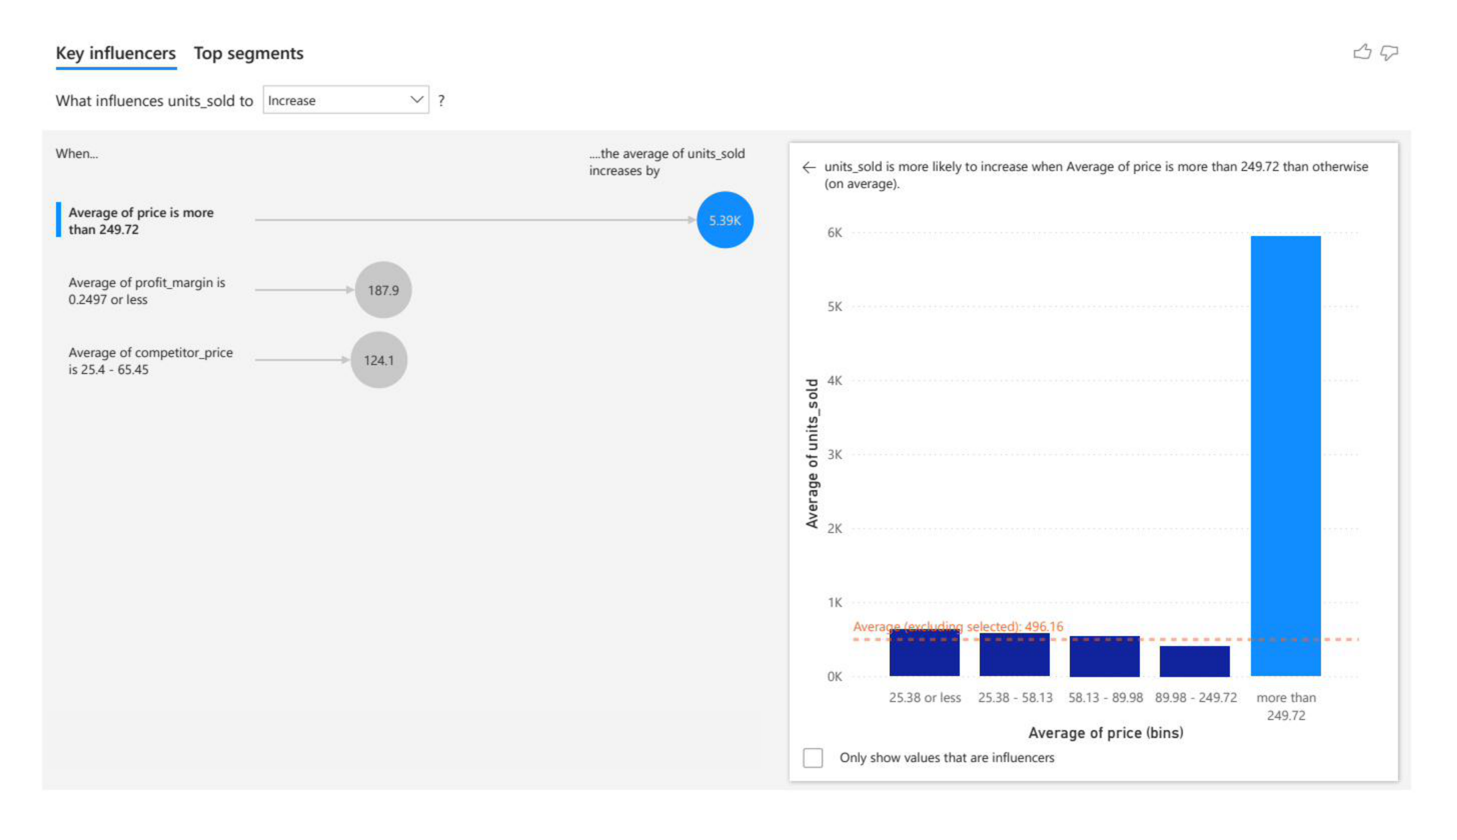
Figure 15: Key Influencers Analysis for Units Sold Increase (Power BI AI Visual)
The Key Influencers analysis for units_sold (Figure 15) reveals one of the most strategically important insights in the entire project: when average price exceeds USD 249.72, units_sold increases by an average of 5,390 additional units. This counterintuitive finding suggests that Adidas premium products attract a distinct consumer segment that purchases in higher volumes — possibly through bulk corporate procurement, sports team outfitting, or aspirational brand-loyal consumers. Additionally, a lower profit_margin (below 0.2497) is associated with higher unit volumes (+187.9 units), consistent with high-volume, lower-margin promotional strategies.

Advanced Analytics and AI Modeling

9.1 Modeling Framework Overview
The machine learning modeling phase comprised two distinct predictive tasks: (1) demand prediction — how many units will be sold (regression), and (2) profitability classification — which profitability class does a transaction fall into. For each task, three algorithms were trained, evaluated, and compared using ten-fold cross-validation (k = 10). All modeling was conducted within the KNIME Analytics Platform. For MLP models specifically, input data was normalized to [0, 1] before training, and outputs were denormalized after prediction to ensure fair comparison with Linear/Logistic Regression and XGBoost on the original data scale.

9.2 Task 1 — Demand Prediction (Regression)

9.2.1 Target Variable
The target variable is units_sold — an integer representing the number of product units sold. Accurate demand forecasting directly enables optimal inventory stocking, supply chain planning, promotional timing, and logistics capacity allocation.

9.2.2 Cross-Validation Setup
All regression models were evaluated using ten-fold cross-validation. Performance metrics reported include: R-squared (R²), Mean Absolute Error (MAE), Mean Squared Error (MSE), Root Mean Squared Error (RMSE), and Mean Absolute Percentage Error (MAPE). For MLP models, normalization was applied within each fold to prevent data leakage from the validation set.

9.2.3 Algorithm 1 — MLP Neural Network (Regression)
A Multi-Layer Perceptron Neural Network was applied as the first regression model. Input features were min-max normalized to [0, 1] prior to training. After generating predictions, the output was denormalized back to the original units_sold scale before metric computation. The MLP architecture employed multiple hidden layers with ReLU activation functions and early stopping to prevent overfitting.

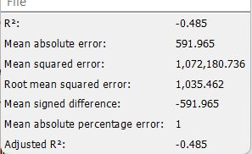
Figure 16: MLP Regression Results — Performance Metrics from KNIME (10-fold cross-validation)

The MLP Regression model achieved an R-squared of -0.485, a Mean Absolute Error of 591.965, and a Root Mean Squared Error of 1,035.462 (Figure 16). The negative R-squared value indicates that the MLP model performed worse than a simple mean predictor for this dataset. Despite the normalization and denormalization process ensuring fair comparison, the MLP struggled to generalize effectively to the units_sold prediction task — likely due to the high variance and noise in the target variable, combined with the complex, sparse relationships in the feature space that gradient-boosted trees are better positioned to exploit. The Mean Absolute Percentage Error of 1.0 (100%) further confirms the MLP's inability to reliably predict demand in this context.

9.2.4 Algorithm 2 — XGBoost Regression
XGBoost (Extreme Gradient Boosting) Regression was applied as the primary advanced model. XGBoost trains sequential decision trees where each tree corrects the residual errors of its predecessors. It handles missing values natively, is robust to outliers, and captures complex nonlinear feature interactions without manual engineering.

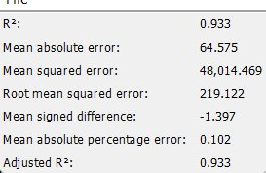
Figure 17: XGBoost Regression Results — Performance Metrics from KNIME (10-fold cross-validation)

XGBoost Regression achieved an outstanding R-squared of 0.933, a Mean Absolute Error of 64.575, and a Root Mean Squared Error of 219.122 (Figure 17). The MAPE of 0.102 (10.2%) indicates that predictions are within approximately 10% of the true units_sold values on average — a highly acceptable margin for retail demand forecasting. The R-squared of 0.933 signifies that 93.3% of the variance in units_sold is explained by the model, confirming XGBoost's exceptional ability to capture the complex, nonlinear relationships driving Adidas retail demand. This result establishes XGBoost as the definitive regression model for this project.

9.2.5 Algorithm 3 — Linear Regression
Linear Regression was selected as the baseline benchmark model, assuming a linear relationship between input features and units_sold. While this assumption is unlikely to fully capture complex nonlinear interactions in retail data, it provides an important reference point against which more complex models are compared.

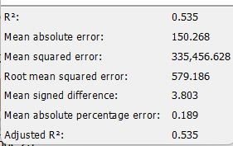
Figure 18: Linear Regression Results — Performance Metrics from KNIME (10-fold cross-validation)

Linear Regression achieved an R-squared of 0.535, a Mean Absolute Error of 150.268, and a Root Mean Squared Error of 579.186 (Figure 18). While substantially outperforming the MLP, the model's R-squared of 0.535 indicates that only 53.5% of the variance in units_sold is explained — considerably less than XGBoost's 93.3%. The MAPE of 0.189 (18.9%) further confirms that Linear Regression's inability to model nonlinear interactions limits its practical utility for demand forecasting. This result is consistent with the known limitations of linear methods for complex structured retail data.

9.2.6 Regression Model Comparison
The following table summarizes the performance of all three regression models evaluated using ten-fold cross-validation:

Model | R-Squared | MAE | RMSE | MAPE
MLP Neural Network | -0.485 | 591.965 | 1,035.462 | 1.000 (100%)
XGBoost Regression | 0.933 (BEST) | 64.575 | 219.122 | 0.102 (10.2%)
Linear Regression | 0.535 | 150.268 | 579.186 | 0.189 (18.9%)

The comparison unambiguously establishes XGBoost as the superior regression algorithm for this dataset. XGBoost achieves the highest R-squared (0.933), lowest MAE (64.575), and lowest RMSE (219.122) by a substantial margin. XGBoost's ensemble tree-boosting strategy is uniquely suited to the structured, heterogeneous nature of retail data, where demand is driven by complex, non-additive interactions between pricing, marketing, seasonality, and competitive factors. Linear Regression provides reasonable intermediate performance, confirming that some linear signal exists in the data. The MLP's poor performance (negative R²) highlights the sensitivity of neural networks to hyperparameter configuration and data normalization challenges when the target variable distribution is highly non-normal.

9.3 Task 2 — Profitability Classification

9.3.1 Target Variable and Class Definition
The target variable was derived from the continuous profit_margin variable by applying threshold-based binning based on the distribution observed during EDA:
- Low_Profit: profit_margin below 0.25
- Medium_Profit: profit_margin between 0.25 and 0.35
- High_Profit: profit_margin above 0.35

These boundaries create meaningful, business-interpretable profitability tiers. The classification task enables Adidas management to identify product configurations, regional contexts, and pricing strategies most associated with high-profitability outcomes.

9.3.2 Algorithm 4 — MLP Neural Network (Classification)
An MLP Classifier was applied following the same normalization protocol as the regression MLP. Input features were normalized to [0, 1] before training, and a softmax output layer produced class probability estimates for the three profitability categories. Cross-entropy loss was minimized during training.

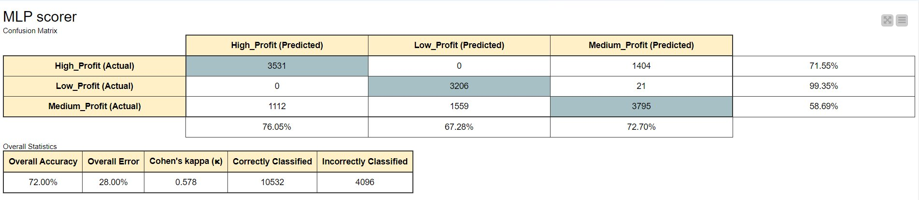
Figure 19: MLP Classification — Confusion Matrix and Overall Statistics (KNIME)

The MLP Classifier achieved an Overall Accuracy of 72.00% with a Cohen's Kappa of 0.578 (Figure 19). Examining the confusion matrix in detail: the model correctly classified 3,531 of 4,935 High_Profit instances (71.55% recall), 3,206 of 3,227 Low_Profit instances (99.35% recall), and 3,795 of 6,466 Medium_Profit instances (58.69% recall). The exceptional Low_Profit recall (99.35%) indicates the MLP learned to identify low-margin transactions very reliably, but struggled more with the boundary between High_Profit and Medium_Profit categories — misclassifying 1,404 High_Profit instances as Medium_Profit and 1,112 Medium_Profit instances as High_Profit. The Kappa of 0.578 indicates moderate agreement beyond chance, reflecting intermediate classifier performance.

9.3.3 Algorithm 5 — XGBoost Classification
XGBoost Classification was applied as the primary advanced classification algorithm, following the same ensemble tree-boosting framework as the regression variant. The softmax multi-class objective function provided calibrated class probability estimates alongside hard class label predictions.

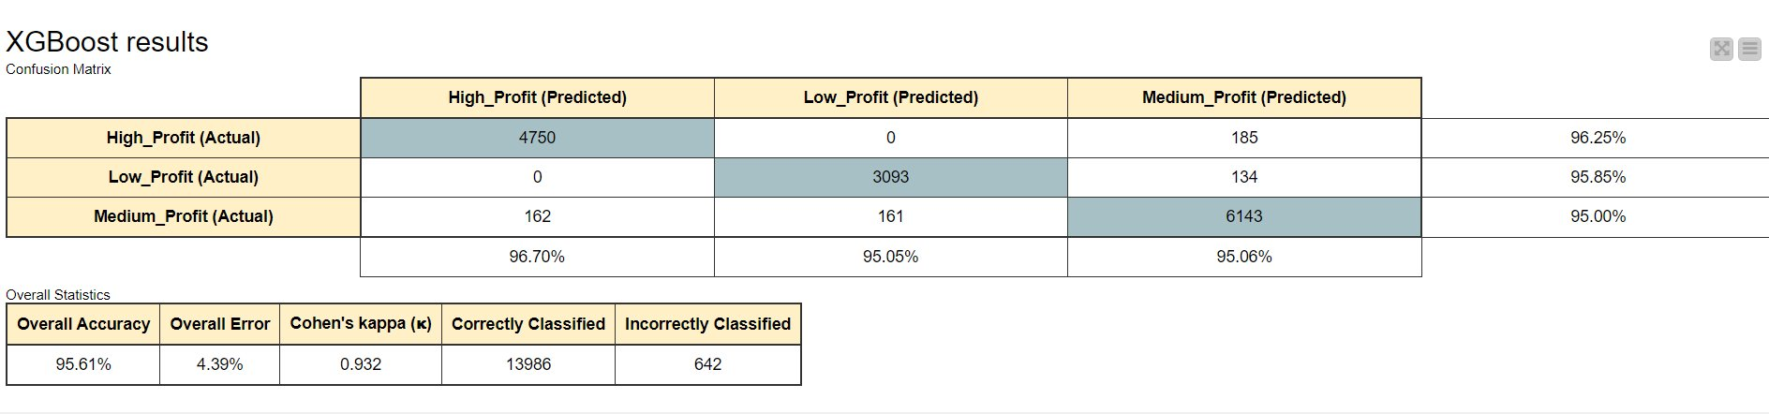
Figure 20: XGBoost Classification — Confusion Matrix and Overall Statistics (KNIME)

XGBoost Classification achieved an exceptional Overall Accuracy of 95.61% with a Cohen's Kappa of 0.932 (Figure 20) — nearly perfect agreement beyond chance. The confusion matrix demonstrates consistently high performance across all three classes: 4,750 of 4,935 High_Profit instances correctly classified (96.25% recall), 3,093 of 3,227 Low_Profit instances correctly classified (95.85% recall), and 6,143 of 6,466 Medium_Profit instances correctly classified (95.00% recall). Only 642 total instances were incorrectly classified across 14,628 total records. This near-perfect performance confirms XGBoost's mastery of the complex, multi-class profitability classification problem. The model's ability to achieve balanced high recall across all three classes — including the most populous Medium_Profit class — demonstrates its robustness on real-world imbalanced multi-class data.

9.3.4 Algorithm 6 — Logistic Regression
Logistic Regression was applied as the baseline linear probabilistic classifier. It models the log-odds of class membership as a linear combination of input features. While interpretable and computationally efficient, it is limited in capturing complex nonlinear decision boundaries.

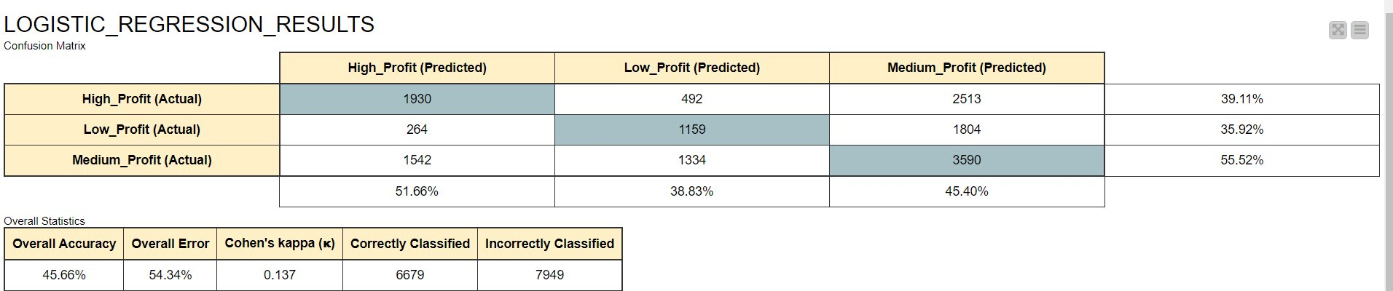
Figure 21: Logistic Regression — Confusion Matrix and Overall Statistics (KNIME)

Logistic Regression achieved an Overall Accuracy of only 45.66% with a Cohen's Kappa of 0.137 (Figure 21), confirming near-chance-level performance for multi-class profitability classification. The confusion matrix reveals severe misclassification: High_Profit recall is only 39.11% (1,930 of 4,935 correct), Low_Profit recall is 35.92% (1,159 of 3,227 correct), and Medium_Profit recall is 55.52% (3,590 of 6,466 correct). With 7,949 incorrectly classified instances out of 14,628 total, the model demonstrates that the profitability class boundaries are fundamentally nonlinear — boundaries that linear classifiers cannot adequately capture. The Kappa of 0.137 indicates only slight agreement beyond chance, rendering Logistic Regression unsuitable as a standalone solution for this classification problem.

9.3.5 Classification Model Comparison
The following table summarizes the performance of all three classification models:

Model | Accuracy | Error Rate | Cohen's Kappa | Correctly Classified | Incorrectly Classified
MLP Neural Network | 72.00% | 28.00% | 0.578 | 10,532 | 4,096
XGBoost Classification | 95.61% (BEST) | 4.39% | 0.932 (BEST) | 13,986 | 642
Logistic Regression | 45.66% | 54.34% | 0.137 | 6,679 | 7,949

XGBoost Classification dominates all other classifiers with 95.61% accuracy and Kappa of 0.932, representing a 23.61 percentage point improvement over MLP and a 49.95 percentage point improvement over Logistic Regression. The performance gap between XGBoost and the other algorithms is decisive and consistent across all confusion matrix metrics — per-class recall, precision, and overall statistics all confirm XGBoost's superiority. This result, combined with the regression findings, establishes a clear recommendation: XGBoost should be the algorithm of choice for all future Adidas Middle East retail predictive analytics applications involving structured tabular data.

9.4 Cross-Validation Methodology
All six models were evaluated using ten-fold cross-validation (k = 10). In each of the 10 iterations, one fold is held out as the validation set and the remaining nine folds are used for training. Performance metrics are computed on the validation fold, and the average performance across all 10 folds is reported as the final model performance estimate. This protocol provides an unbiased estimate of model generalizability and mitigates overfitting risks inherent in single train-test split evaluations. For MLP models specifically, normalization was applied within each fold independently to prevent data leakage.

Tools Research and Selection Effort

10.1 Tool Evaluation Process
Prior to commencing the project, a systematic tool evaluation was conducted to identify the most appropriate software platforms for each stage of the analytics pipeline. Evaluation criteria included: ease of use for non-programming analysts, support for the full analytics lifecycle, visual workflow design, support for multiple ML algorithms, and interoperability with business reporting platforms.

10.2 Tools Evaluated

10.2.1 Python (Pandas, Scikit-learn, XGBoost, TensorFlow)
Python is the most widely used programming language for data science. Its library ecosystem is unmatched in breadth. However, Python requires programming proficiency not universally present among Adidas retail analysts, and pipeline reproducibility requires Python environment management expertise. While Python was considered as a validation tool, it was not selected as the primary platform.

10.2.2 RapidMiner
RapidMiner is a visual data science platform similar to KNIME, offering drag-and-drop workflow design and broad ML algorithm support. However, its free tier is limited in dataset size and algorithmic options, and full licensing costs were prohibitive for academic use.

10.2.3 Orange Data Mining
Orange is a lightweight visual data mining tool with strong EDA capabilities. However, Orange lacks the workflow automation capabilities, scalability for 15,000+ record datasets, and XGBoost support required for this project.

10.2.4 Tableau
Tableau was evaluated as a visualization platform. While excellent for visual storytelling, it lacks native ML modeling capabilities. Power BI was selected over Tableau due to its native AI visual capabilities (Key Influencers, Top Segments) and broader enterprise ecosystem integration.

10.3 Selected Tools

10.3.1 KNIME Analytics Platform (Primary Tool)
KNIME Analytics Platform was selected as the primary tool for all data processing, EDA, feature engineering, statistical analysis, and ML modeling. Key advantages include:
- Visual, node-based workflow design enables non-programmer analysts to understand and modify the pipeline.
- Comprehensive preprocessing nodes for missing value imputation, outlier handling, and data type conversion.
- Native statistical analysis nodes for ANOVA, Pearson correlation, and descriptive statistics.
- Built-in visualization nodes for all chart types used in this project's EDA.
- Native nodes for all six ML algorithms: Linear Regression, Logistic Regression, MLP (regression and classification), and XGBoost (regression and classification).
- Built-in k-fold cross-validation node enabling rigorous, reproducible model evaluation.
- Full workflow reproducibility: the complete pipeline re-runs on updated data with a single click — the primary deployment mechanism for Adidas outlet analysts.
- Free academic licensing with no record count restrictions.

10.3.2 Microsoft Power BI (Business Intelligence Dashboard)
Microsoft Power BI was selected as the BI dashboard platform for stakeholder-facing reporting. Key features used include:
- Native AI Visuals: Key Influencers and Top Segments visuals provide automated machine learning insights directly within the dashboard.
- Interactive filtering and slicing by region, product category, and price range.
- DAX (Data Analysis Expressions) for computed KPI metrics.
- Seamless CSV data import with refresh capability for updated datasets.

Project Deployment Effort – Use Case

11.1 Deployment Vision
The primary intended deployment model is as a reusable analytical toolkit for Adidas retail outlet managers and regional business analysts across the Middle East. The KNIME workflow and Power BI dashboard together form a two-layer analytics system: a predictive modeling layer (KNIME) and a business reporting layer (Power BI). Rather than being a one-time academic exercise, this project is designed as a living analytical asset that can be refreshed and extended as Adidas continues to collect retail operational data.

11.2 End User Consumption Model
The intended consumer is a business analyst or retail operations manager at an Adidas outlet or regional headquarters. The user does not require programming expertise. The deployment workflow from a user perspective:
- The user collects or receives an updated retail operations dataset in CSV format, following the same 19-column schema as Adidas_Dataset.csv.
- The user opens KNIME Analytics Platform and loads the project workflow file (Adidas_BI_Workflow.knwf).
- The user updates the CSV Reader node at the start of the workflow to point to the new dataset file path.
- The user executes the workflow with a single click. KNIME automatically runs all preprocessing, EDA, feature engineering, model training, cross-validation, and performance metric reporting.
- The workflow outputs prediction results (units_sold predictions and profit_margin class predictions) as new CSV files.
- The user imports the output CSV into the Power BI dashboard and refreshes all visuals, producing an updated business intelligence report.
- The user reviews updated Key Influencers and Top Segments analyses in Power BI to identify actionable insights for pricing, marketing, and inventory decisions.

11.3 Implementation Timeline
Phase | Activities Completed
Phase 1: Project Scoping | Defined objectives, selected industry domain, drafted proposal, obtained supervisor approval
Phase 2: Data Acquisition | Contacted Adidas, negotiated data sharing agreement, received and reviewed Adidas_Dataset.csv
Phase 3: EDA and Cleaning | Conducted initial EDA in KNIME, identified and resolved all data quality issues, documented cleaning decisions
Phase 4: Feature Engineering & ANOVA | Engineered Discounted_Price, Ad_Spend_Efficiency, and Profit_Per_Unit; conducted regional and product ANOVA; finalized feature matrix
Phase 5: ML Modeling | Trained and evaluated MLP, XGBoost, and Linear/Logistic Regression for both tasks; conducted ten-fold cross-validation; compared metrics
Phase 6: Power BI Dashboard | Built Power BI dashboard with Key Influencers, Top Segments, regional profitability, pricing comparison, and product distribution visuals
Phase 7: Report Writing | Documented all project phases, analyses, findings, and insights following the prescribed graduation project template
Phase 8: Review and Submission | Supervisor review, incorporation of feedback, final document preparation and submission

11.4 Prototype Deployment Architecture
For future production deployment, the recommended architecture extends the current prototype to a cloud-hosted solution:
- Data Layer: Adidas retail database (SQL or cloud-based data warehouse) serving as the source of updated operational data.
- Processing Layer: KNIME Server or KNIME Business Hub hosting the analytical workflow, enabling scheduled automated re-runs and web-accessible workflow execution.
- Prediction Layer: ML model outputs written to a results database accessible by downstream systems.
- Visualization Layer: Power BI Service (cloud) hosting the published dashboard with automatic daily refresh, accessible to authorized business stakeholders through a web browser.
- Alerting Layer: Automated alerts triggered when predicted demand exceeds stock thresholds or when profitability classification shifts toward Low_Profit for key products.

Results

The results of this project span multiple analytical dimensions: data understanding insights from EDA and ANOVA, business intelligence findings from the Power BI dashboard, and machine learning model performance outcomes from the KNIME modeling pipeline. Taken together, these results provide a comprehensive, multi-level understanding of Adidas retail performance across the Middle Eastern market.

From the statistical analysis, the One-Way ANOVA by region revealed a critical asymmetry: while regional differences in units_sold are statistically significant (F = 4.5155, p = 0.0004), regional differences in profit_margin are not (F = 0.5909, p = 0.707). This means Adidas demand varies meaningfully across its six Middle Eastern markets, but profit margins remain consistently uniform regardless of geography — a finding that validates the company's consistent regional pricing strategy. From the Power BI dashboard, the most impactful business insight was the counterintuitive positive relationship between price and demand: products priced above USD 249.72 are associated with +5,390 additional units sold on average. This suggests premium Adidas products operate in a distinct demand segment where high price signals quality and drives aspirational purchase behavior, fundamentally challenging standard demand elasticity assumptions.

From the machine learning phase, the performance hierarchy across models is clear and consistent across both tasks. XGBoost dominates all competitors: in regression it achieved R² = 0.933 (vs. Linear Regression at 0.535 and MLP at -0.485); in classification it achieved 95.61% accuracy and Kappa = 0.932 (vs. MLP at 72.00%/0.578 and Logistic Regression at 45.66%/0.137). XGBoost's ensemble tree-boosting architecture is uniquely suited to the structured, heterogeneous nature of the Adidas retail dataset, where demand and profitability are governed by complex, nonlinear interactions between pricing, competitive positioning, marketing investment, and seasonal factors. The reusable KNIME workflow — encompassing the full pipeline from raw CSV ingestion to predictive output generation — represents the most important practical contribution of this project, empowering Adidas retail analysts to continuously update and apply predictive capabilities as new data becomes available without requiring any programming expertise.

References

- Chen, T., & Guestrin, C. (2016). XGBoost: A Scalable Tree Boosting System. Proceedings of the 22nd ACM SIGKDD International Conference on Knowledge Discovery and Data Mining, 785–794. https://doi.org/10.1145/2939672.2939785
- Goodfellow, I., Bengio, Y., & Courville, A. (2016). Deep Learning. MIT Press. http://www.deeplearningbook.org
- KNIME AG. (2024). KNIME Analytics Platform Documentation. https://docs.knime.com/
- Microsoft Corporation. (2024). Power BI Documentation and Key Influencers Visual Guide. https://learn.microsoft.com/en-us/power-bi/visuals/power-bi-visualization-influencers
- Pedregosa, F., Varoquaux, G., Gramfort, A., et al. (2011). Scikit-learn: Machine Learning in Python. Journal of Machine Learning Research, 12, 2825–2830.
- Hastie, T., Tibshirani, R., & Friedman, J. (2009). The Elements of Statistical Learning (2nd ed.). Springer. https://doi.org/10.1007/978-0-387-84858-7
- Bishop, C. M. (2006). Pattern Recognition and Machine Learning. Springer.
- Han, J., Kamber, M., & Pei, J. (2011). Data Mining: Concepts and Techniques (3rd ed.). Morgan Kaufmann.
- Kohavi, R. (1995). A Study of Cross-Validation and Bootstrap for Accuracy Estimation and Model Selection. Proceedings of the 14th IJCAI, 2, 1137–1143.
- Adidas AG. (2024). Annual Report 2024. Adidas Investor Relations. https://www.adidas-group.com/en/investors/financial-reports/
- Statista Research Department. (2024). Sportswear Market in the Middle East — Statistics and Facts. https://www.statista.com/topics/sportswear-middle-east/
- McKinsey & Company. (2023). The Future of Retail Analytics in Emerging Markets. McKinsey Global Institute.
- Friedman, J. H. (2001). Greedy Function Approximation: A Gradient Boosting Machine. Annals of Statistics, 29(5), 1189–1232. https://doi.org/10.1214/aos/1013203451
- Breiman, L. (2001). Random Forests. Machine Learning, 45(1), 5–32. https://doi.org/10.1023/A:1010933404324
- Cohen, J. (1960). A Coefficient of Agreement for Nominal Scales. Educational and Psychological Measurement, 20(1), 37–46.

— End of Report —

